Lab 1-1 Creating Requests in Siebel Answers
Goals | To create and format requests
Scenario | You need to extract data from the Supplier Sales subject area and format the results.
Outcome | You will have saved formatted requests that return analytics data.
Time | 20 – 25 minutes
Environment | 
Instructions:
- Verify NQSConfig.ini is set to read the appdev repository.
  - Double-click C:\SiebelAnalytics\Config\NQSConfig.INI.
  - Locate the [REPOSITORY] section and, if necessary, modify as follows (comment out all repositories except appdev.rpd):
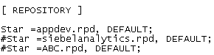
  - Select File > Save.
  - Select File > Exit.
- Restart Siebel Analytics services.
  - Double-click the Services shortcut on the desktop.
  - Restart Siebel Analytics Server and Siebel Analytics Web services.
  - Minimize the Services window.
- Start Siebel Analytics Web
  - Select Start > Programs > Siebel Analytics > Siebel Analytics Web.
  - Enter the following information to log in:
User ID | Administrator
Password | Administrator
  - Click Log In.
- Click Answers to navigate to the Siebel Answers start page.
- In the Subject Areas section, click SupplierSales. The SupplierSales subject area appears in the left selection pane.
- Expand the Customers table to display the columns.
- List the columns in the Customers table:
- Create a request for customers by state.
  - In the Customers table, click the State column. What happens in the right pane?
  - In the Customers table, click the Customer column. What happens in the right pane?
- Review the results of the request you just created.
  - In the right pane, click the Results tab
  - Notice that the results appear in a table format. This is the default.
  - Scroll down and click the Next Page button 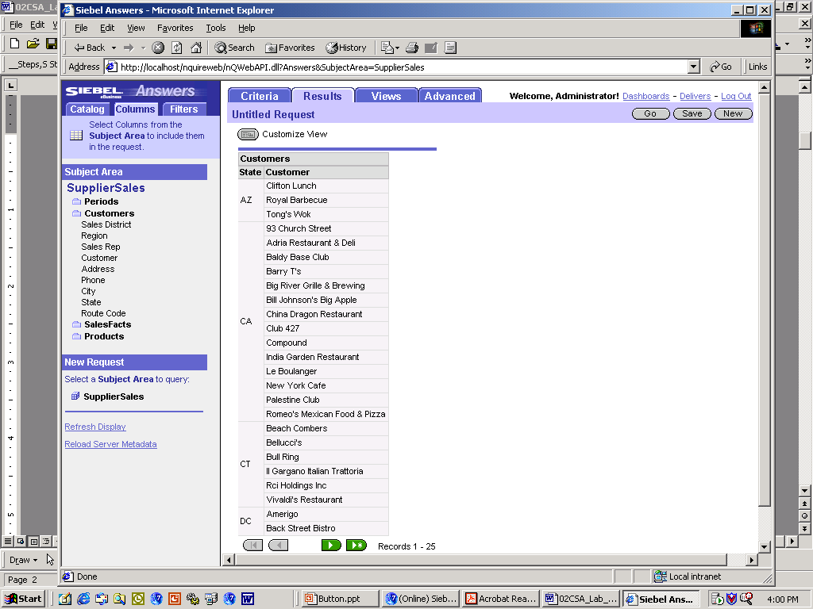to view the next set of rows in the table.
  - Click the All Pages button to view all the rows in the table.
  - How many rows of data are in the table for this request?
- Modify the request by adding a column.
  - Click the Criteria tab.
  - Expand the SalesFacts table and select the Dollars column. The Dollars column is added to the request. Check your criteria:
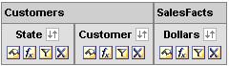
  - Click the Results tab to view the results.
- Save the request in a new folder.
  - Click the Save Request button. The Choose Folder window opens.
  - Click the Create Folder button. The Create Folder window opens.
  - Name the new folder by typing My Sales in the Caption field.
  - Click OK. A new folder is created in My Folders.
  - Click the My Sales folder.
  - In the Name field, type Sales by State.
  - Click OK.
  - The request is saved in the My Sales folder in the My Folders section of the catalog.
- View the saved request in the catalog.
  - Click the Answers link.
  - In the Catalog section, select My Folder > My Sales to see your saved request.
  - Click Sales by State. What happens?
  - Click the Modify button. What happens?
- Modify the request to sort data by state, then by dollars in descending order.
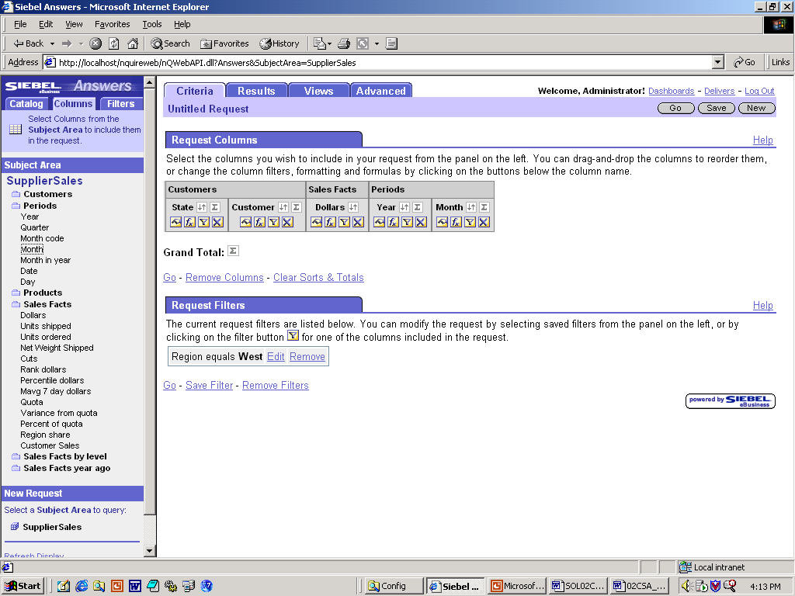
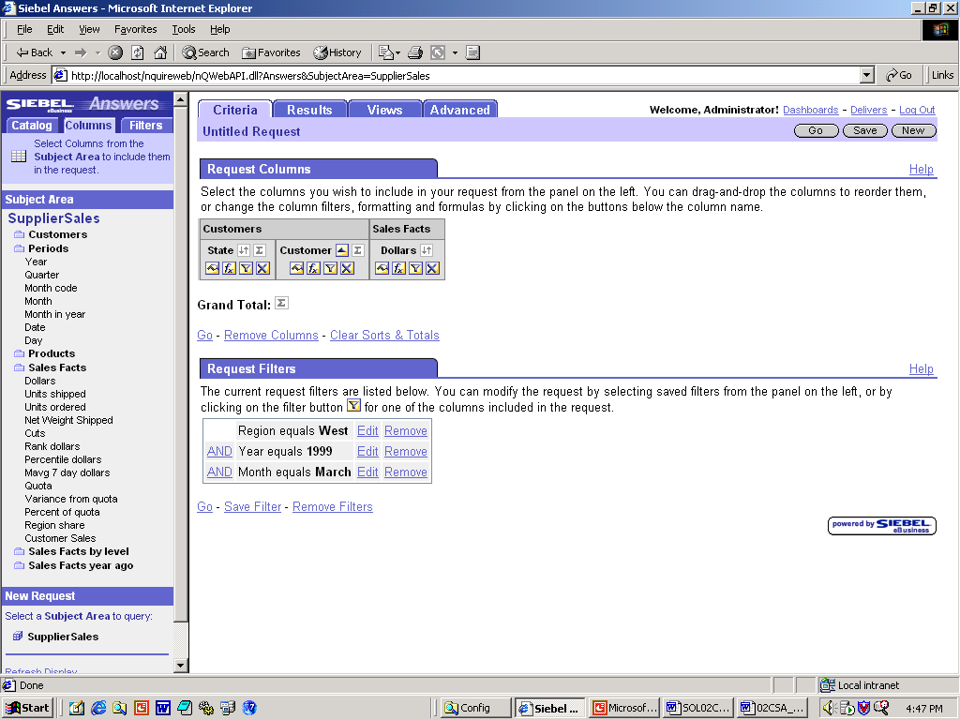
  - Click the Order By icon on the State column. The icon changes to the Order Ascending icon .
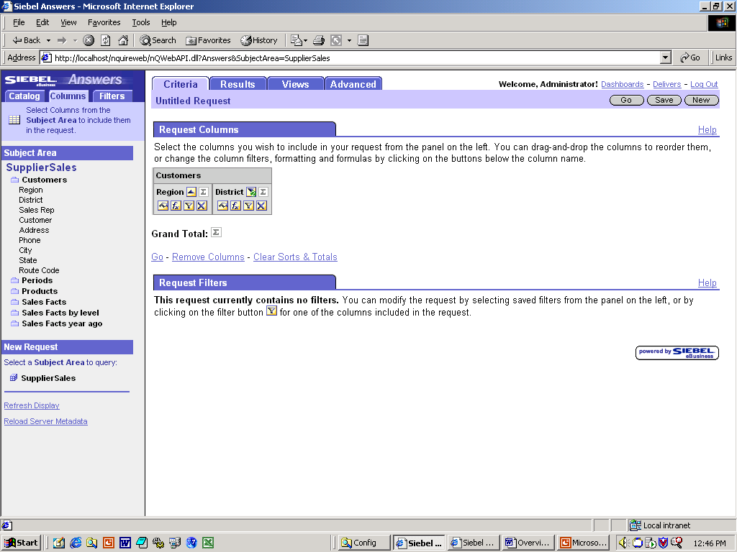
  - Click the Order By icon twice on the Dollars column. The icon changes to the Order Descending icon with a 2.
Note: The 2 on the icon indicates that this is a secondary sort. In this case, the State column represents the primary sort.
- Click the Results tab to verify the sort.
- Format dollars to appear as whole dollar amounts without decimal points.
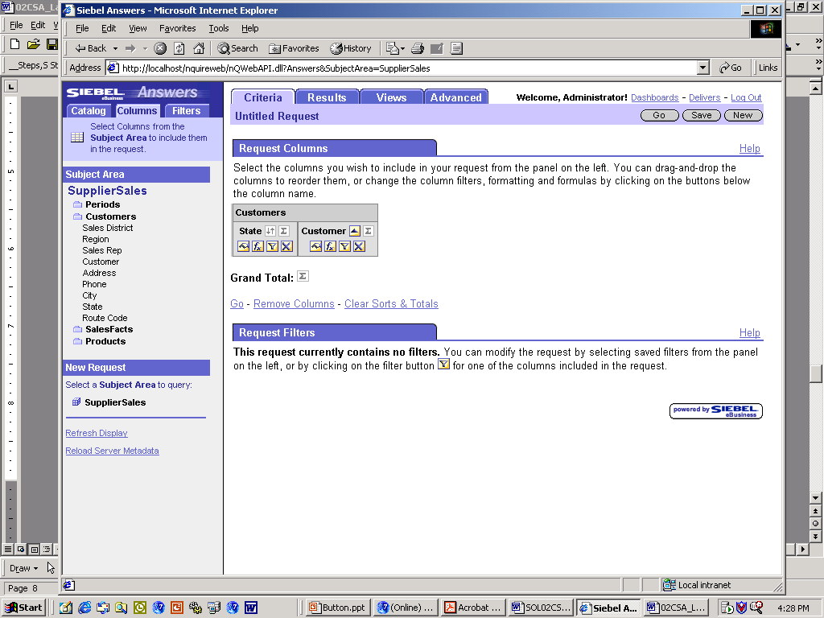
  - Click the Criteria tab.
  - Click the Format Column icon in the Dollars column. The Column Properties window opens.
  - Click the Value Format tab.
  - Check the Override Default Data Format check box.
  - Select Currency from the Treat Numbers As drop-down list.
  - Select $ from the Currency Symbol drop-down list.
  - Select 0 from the Digits drop-down list. Digits represent the numbers after the decimal.
  - Click OK.
- Click the Results tab to verify the formatting.
- Center the alignment of the customer column.
  - Click the Criteria tab.
  - Click the Format Column icon in the Customer column. The Column Properties window opens.
  - Click the Value Format tab.
  - Select Center from the Horizontal Alignment field drop-down list.
  - Click OK.
- Click the Results tab to view the alignment change.
- Repeat the process and set the Vertical Alignment of the State column to Top and examine the results.
- Return the Customer column settings back to the defaults and check the results.
- Modify the Customer column heading.
  - Click the Criteria tab.
  - Click the Format Column icon in the Customer column.
  - Click the Column Format tab.
  - Select the Custom Headings check box.
  - Type Customer Name in the Column Heading field.
  - Click OK.
- Navigate to the Criteria and Results tabs and verify that the new name is displayed in both places.
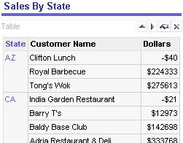
- Change the Customer column name back to the original name.
  - Click the Format Column icon.
  - Click the Column Format tab.
  - Clear the Custom Headings check box.
  - Click OK.
  - Verify that the name has changed.
- Set up conditional formatting on the Dollar column.
  - Click the Criteria tab.
  - Click the Format Column button on the Dollars column.
  - Click the Conditional Format tab.
    - Click the Add Condition button.
    - Select Dollars from the drop-down list. The Create/Edit Filter window opens.
    - Select is less than from the Operator drop-down list.
    - Enter 250000 in the Value field.
    - Click OK. The Edit Format window opens.
    - Click the Color button.
    - Select red from the color selector and click OK.
    - Select Bold from the Style drop-down list.
    - Click OK.
  - Repeat the process and create the following conditional formatting:
Criteria | Operator/Value | Color | Style
Dollars | is between 250000 and 500000 | Blue | Bold
Dollars | is greater than 500000 | Green | Bold
  - Click OK to close the Column Properties window when you are finished.
  - Click the Results tab to view the conditional formatting.
  - Save this request as a new request in your My Sales folder. Name the request Formatted Sales By State.
- Add filters to your saved request.
  - Click the Answers link.
  - Open the request you just saved, Formatted Sales By State.
    - Click the Catalog tab (in the selection pane).
    - Select My Folders > My Sales and expand the My Sales folder
    - Click the saved request, Formatted Sales By State.
    - Click the Modify button.
  - Add a filter to show only records from the West region.
    - Click Region in the Customers table. The Region column is added to the Columns section on the Criteria tab.
    - Click the Format button in the Region column. The Column Properties window opens.
    - Click the Column Format tab.
    - Check the Hide check box in the upper right corner.
    - Click OK.
    - Click the Add Filter button in the Regions column. The Create/Edit Filter window opens.
    - In the right panel click All Choices, and then click West. Notice that West is added to the Value field.
    - Click OK.
    - Notice you are returned to the Criteria tab and that in the Filters section you have a new filter called “Region is equal to / is in West.”
  - Add an additional filter value to show records from 1999 only. Follow the steps above, using the Periods table and the Year column.
  - Check your filters:
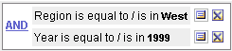
  - Click the Results tab to view the results.
  - How many records appear?
  - Save the filter for use with other content.
    - Click the Criteria tab.
    - Click the Save Filter button. The Choose Folder window opens.
    - Click the My Filters folder.
    - Type West Region, 1999 in the Name field.
    - Click OK.
  - Save the existing request with the filter.
    - Click the Save button.
    - Select My Folder > My Sales.
    - Name the request Formatted Sales by State, West Region 1999.
    - Click OK.
- Add a formula to a request to rank customers by dollar sales and sort by state.
  - In the Dollars column, click the Edit Formula 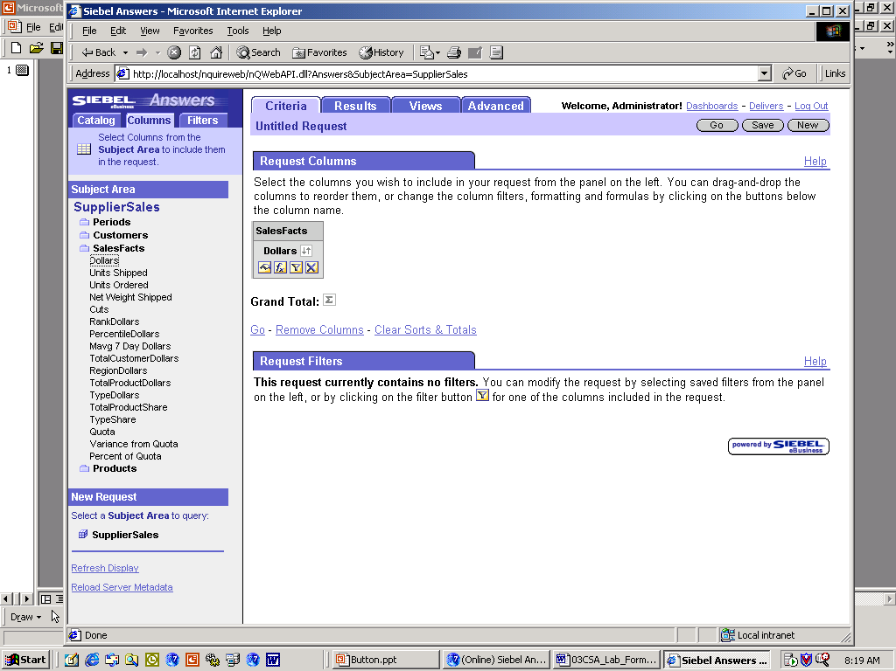 icon. The Edit Column Formula window opens.
  - Add a formula to the request.
    - Follow the syntax Rank(Expr) and manually type the following into the Column Formula field: Rank(SalesFacts.Dollars by Customers.State).
    - Check the Custom Headings box.
    - In the Column Heading field, type (RANK(Dollars BY State).
    - Click OK.
    - Check your request:
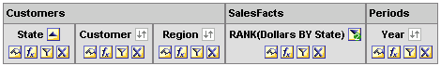
  - Click the Results tab to view the results.
- Customize the Rank(Dollars BY State) column heading:
  - Click the Criteria tab.
  - In the Rank(Dollars BY State) column, click the Format Column icon.
  - Click the Column Format tab.
  - Check the Custom Headings check box.
  - In the Column Heading field, type Ranking to replace the current value.
  - Click the Value Format tab.
  - Uncheck Override Default Data Format.
  - Click OK.
  - Click the Results tab to view the results.
- Save the request to the My Sales folder.
  - Click the Save button. The Choose Folder window opens.
  - Verify that the Folder field indicates My Folders: My Sales.
  - Type Ranked Sales By State in the Name field.
  - Click OK.
- Create a filter for the current and previous month using variables.
Note: You will filter for “current” as defined by the data in the database, not by the calendar.
  - Click the Answers link.
  - Open the Sales By State request in the My Sales folder.
  - Click the Modify button.
  - Add the Month column to the request by selecting Periods, then Month in the selection pane.
  - Click the Add Filter button in the Month column.
  - In the filter Operator field, choose is equal to / is in.
  - Change Value to Variable by clicking the Add button and selecting Variable from the drop-down list.
Note: The administrator has predefined variables called CURRENT_MONTH and PREVIOUS_MONTH.
  - In the Variable field, enter CURRENT_MONTH.
  - Click the Add button and select Variable from the drop-down list.
  - In the Variable field, enter PREVIOUS_MONTH.
  - Click OK.
  - Click the Results tab to preview the results.
  - Save the request as Sales By State for Current and Previous Month in the My Sales folder.
Solutions 1-1 Creating Requests in Siebel Answers
Answers
7. List the columns in the Customers table:
Region, Sales District, Sales Rep, Customer, Address, Phone, City, State, and Route Code
8.a. In the Customers table, click the State column. What happens in the right pane?
The State column is added to the request criteria.
8.b. In the Customers table, click the Customer column. What happens in the right pane?
The Customer column is added to the request criteria.
9.e. How many rows of data are in the table for this request?
136
12.c. Click Sales by State. What happens?
The request is executed and the results are displayed in the workspace.
12.d. Click the Modify button. What happens?
The request is ready for editing.
25.g. How many records appear?
29

